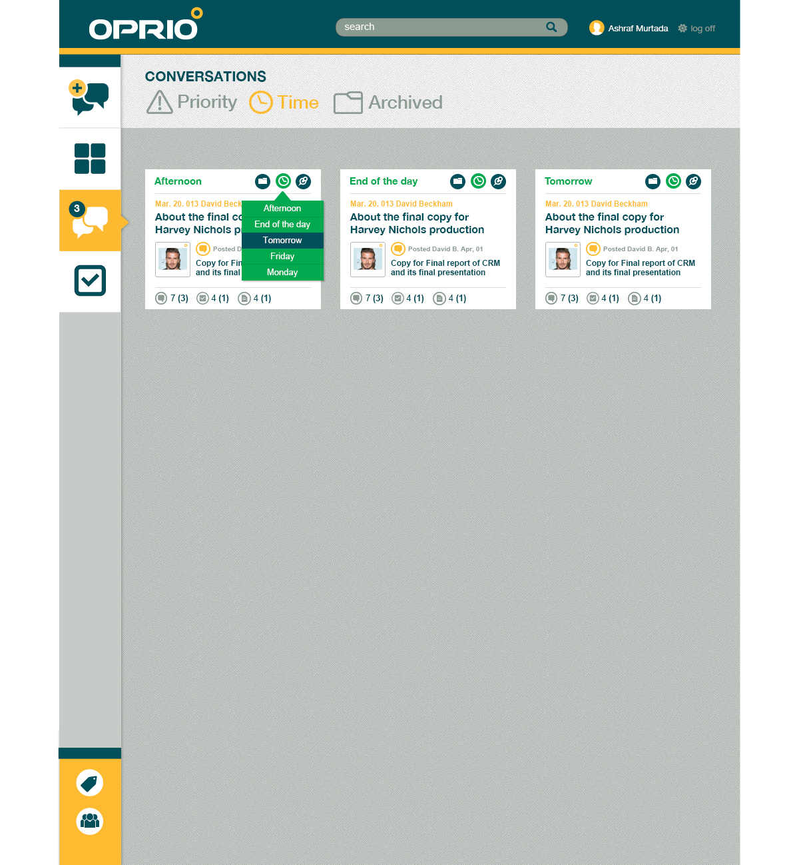

12 

10 

9 

4

6 

7 

8 

5

11 

11 

3

1

2

Please refer to the blue boxes corresponding to the numbered headers

# Main Nav Area

This area is always visible and contains 4 buttons at the top and 2 at the bottom:

1. Add New Conversation
   1. shows a page to add a new conversation
   2. Page takes conversation title, first message, and allows user to add more people to the conversation before posting
2. Hub Page Link (later)
3. Conversations Link
   1. Shows the page above (THIS TASK)
4. Trackables Link (later)
5. Tags Link (bottom, later)
6. Contacts Link (bottom, later)

# Top Banner

* Always visible
* Shows:
  + Search box (this task)
  + Avatar + First Name (this task)
  + Settings
    - Logoff (this task)
    - Preferences (later)
* Search box is contextual. In other words, search is related to the current page the user is on. For example, in this page, search shows conversations only, with an option to expand to other item types. Please see Search section for more details. This functionality is a point where the other dev can work on in parallel.

# Page Title

* “Conversations” just a title

# Page Tabs

* Should use a sliding effect similar to what’s in the old code and in Windows Phone. JS lib is in old code (jquery-metro)
* Priority & Time view only differ in sorting order and item visibility
  + Priority
    - will have an algorithm for ordering. For now, a simple algorithm will be implemented base on:
      * Recency (Last update)
      * Deferred Items move
      * # of non-viewed updates (next task)
      * # of children of items I posted (how many items under my posts) (next task)
    - doesn’t show archived or pinned items.
  + Time View: Based on recency (Last Update)
* Archived View (Later)

# Conversation Card

* Each conversation for the user is represented as a card with a summary of the most important attributes and the last 3 updates.
* Clicking anywhere on the card (except the title) opens the preview pane on the right. See Preview Pane section.

# Convesation Title

* Hyperlink that takes the user to the conversation detail view, which will be implemented later.
* Title should only show as a link when the mouse is hovered over it.

# Recent Item

* Shows in a different color when it’s unread
* For Messages show:
  + Snippet of text
  + Action that happened on message (Posted)
  + Author, Date
* For Trackables show:
  + Snippet of title
  + Action (posted, assigned to somebody, status changed)
  + Author, Date
* For Files show:
  + Snipped of file name
  + File type, size, version
  + Author, Date

# Total Items

* Show item count for each item type (message, trackable, file).
* Read count **(Unread count in parenthesis and bold),** eg. 10 **(2)**

# Pin button

* Pins a conversation to the hub page (set Pinned = true)
* Pinning a conversation removes it from the priority view, but not the time view.
* Animation to hide item

# Defer button

* When clicked, presents the user with a number of deferral options as shown above
* When an option is selected:
  + The selected option is shown near the button
  + The Deferred field in the TagPerson table gets updated with the corresponding date/time based on calculation relative to current user time.
  + Item drops in order in Priority view (Time view doesn’t change)

# Defer Menu (see 11)

# Archive button

* Sets the Archived field date in the TagPerson table
* Item is removed from Priority and Time views
* Item is shown in Archived view (later)\

# Preview Pane (Later)

* Opens up when user clicks on a conversation card (slides in)
* Sticky, should always be visible regardless of scroll position
* Can be closed using the close button (x) or by hitting ESC
* Shows more details about selected conv (details and design later)

# Search (Later)

* Can be worked on by other dev
* Old code as a starting point
* Uses Lucene.Net indexing
* Contextual: Shows results based on current page
* Functionality for the current view (Conv List):
  + Show conversation cards filtered by search terms
  + Search term is matched against:
    - Conversation title
    - Messages text
    - Trackables text
    - File Names
  + As user types, system filters results in real time.
  + Also, as user types, an ‘auto-complete’ style drop down shows a list of matching tags and authors, if any. The user can click on any of these to conduct a search based on that criteria.
  + Visually, the tag results show as “Tag: <tag name>”, while the author results show as “Person: <person name>”
* When search results are displayed, show the following next to page title:
  + (Filtered on ‘<search term>’, Clear (link to clear filter))